1. **Step 01**:   
   Create Spring Boot Microservice Project with dependency “Config Server”.  
   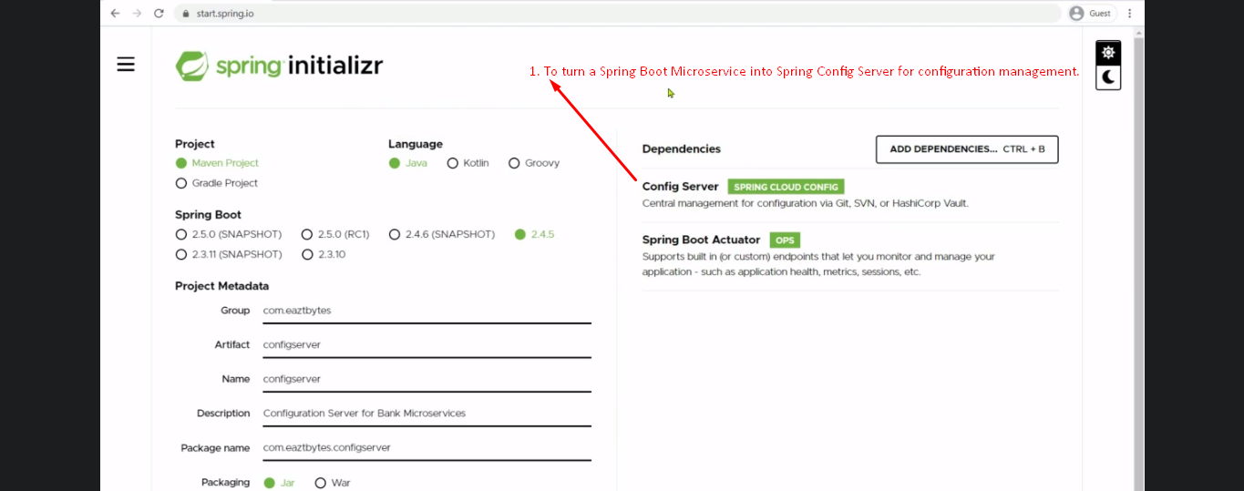  
   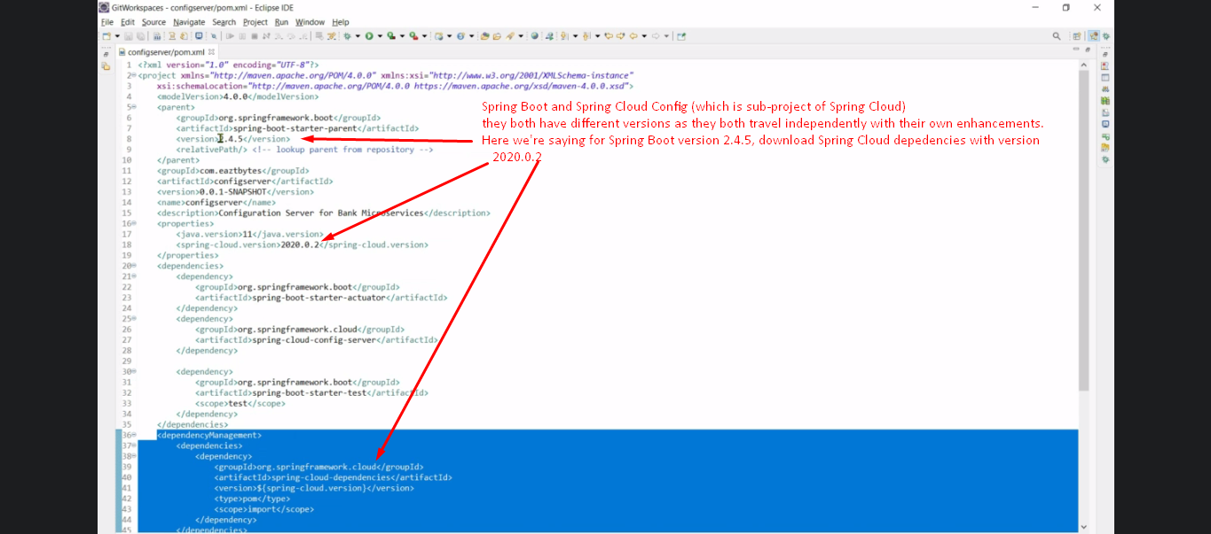
2. Step 02:  
   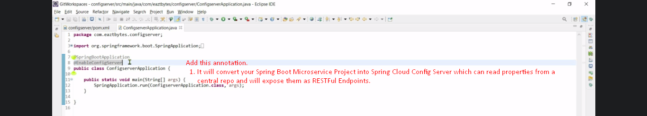
3. Steps 03: Configuration in application.properties.
4. Step 03: Create properties files for different micro services and different environment.  
   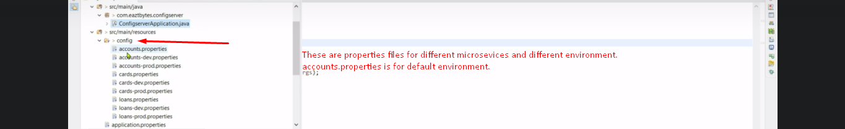
5. Step 04: Properties file location Configuration in classpath.  
   

Local files Location

1. Put the file in local drive:  
   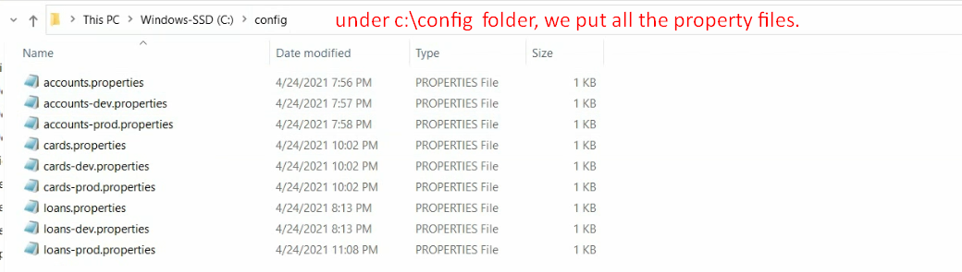
2. application.properties.  
   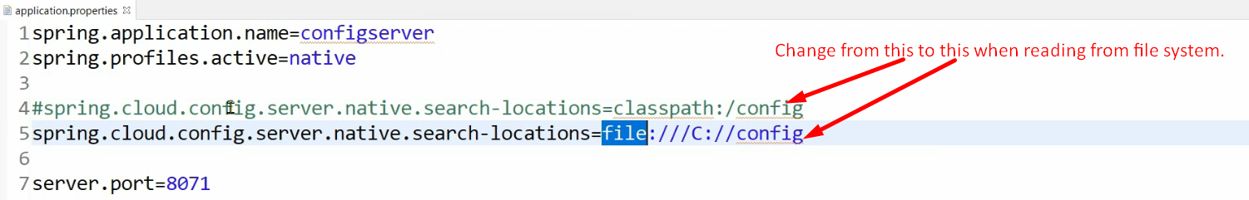

Github Files Location

1. 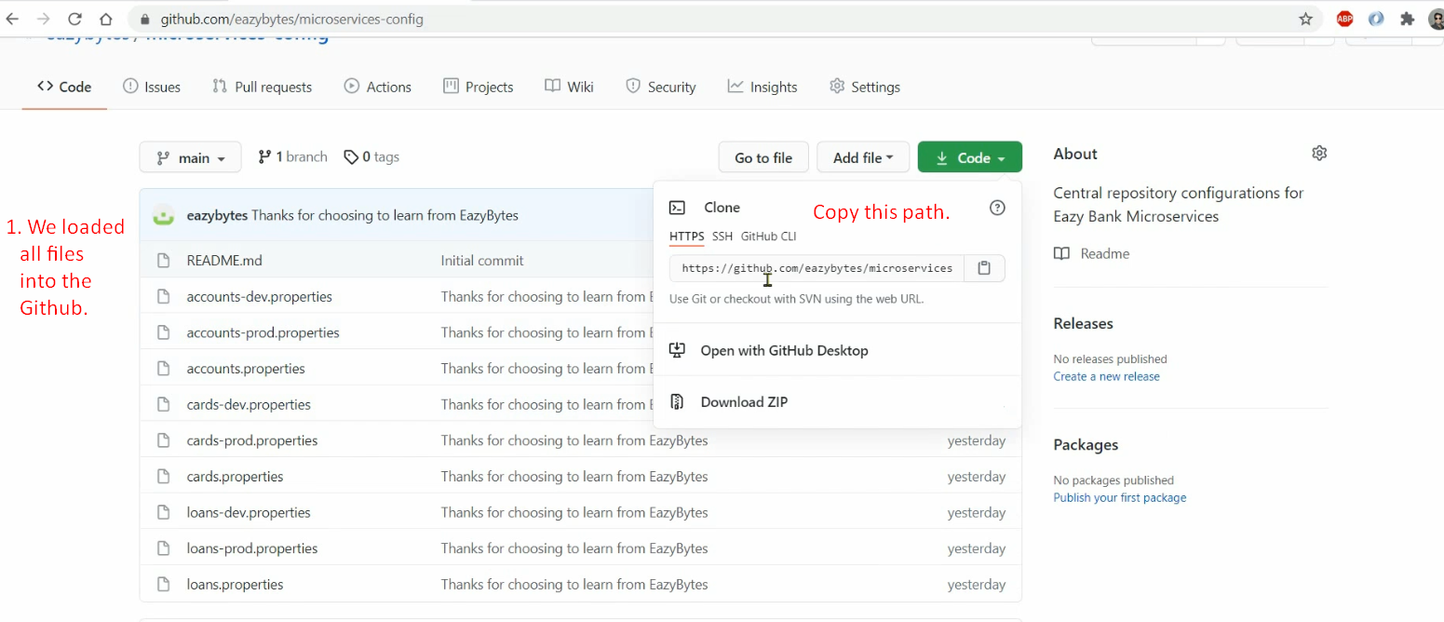
2. 